**1. what is a software? what is software engineering?**

**Ans**- A software is a collection of information, instruction and database.

It is a branch of computer science which deals with design, development, testing and maintenance of the software.

**2. explain types of software**.

**Ans**- Types of software are.

System software.

Application software.

Programming software.

**3. what is SDLC? Explain each phase of SDLC.**

**Ans-** SDLC (SOFTWARE DEVELOPMENT LIFE CYCLE). It clearly defines the processes for creating high quality software.

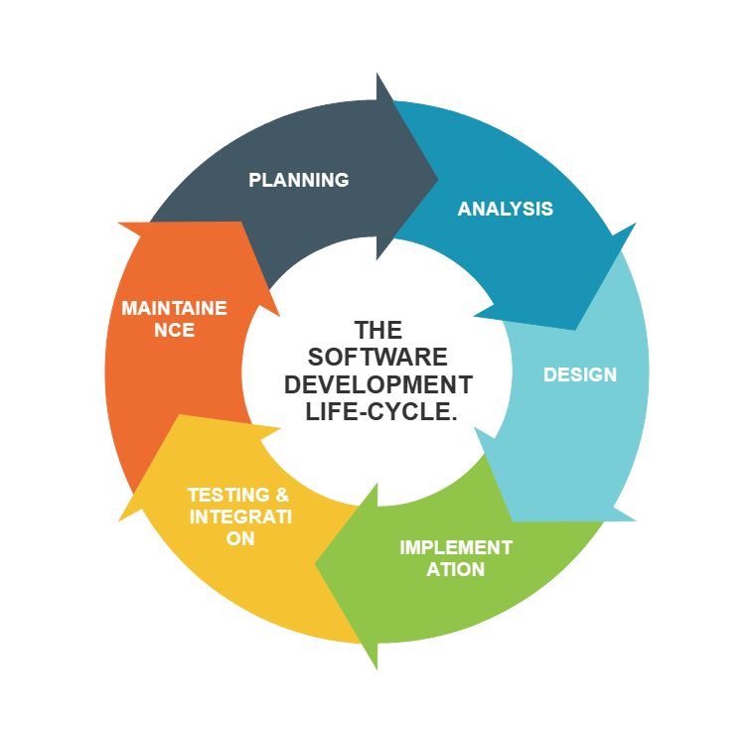

**4. What is DFD? Create a DFD diagram on Flipkart.**

**Ans-** DFD stands for data flow diagram.

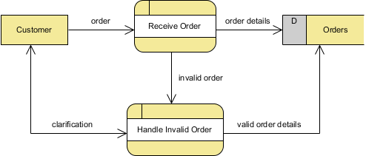

**5. What is Flow Chart? Create a flowchart to make addition of two numbers.**

**Ans-** Flowchart is used to show all the processes step by step

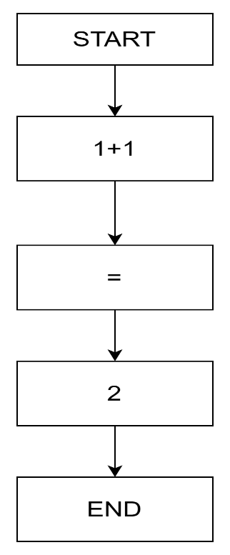

**6. What is use case diagram? Create a use case on bill payment on Paytm.**

**Ans-** Use case diagram describes the high-level functions and scope of the systems. It also identifies the interactions between the systems and its actors.

